**Setting up a WordPress site with AWS EC2**

*Recommend to view in layout



**Contents**

**A)Create your own VPC(optional)\***

**B)Create your instance with AWS**

**C)Create your DNS(optional)\***

**D)Connecting to the Created Remote Instance**

**1)Creating additional user account and configuring SSH key**

**2)Installing wordpress**

**3)Setting up MySQL**

**4)Configure HTTPS using Certbot (Optional)**

**5)Security (Optional)**

**A) Create VPC (Optional)**

**Reading material:** [**https://docs.aws.amazon.com/vpc/latest/userguide/how-it-works.html**](https://docs.aws.amazon.com/vpc/latest/userguide/how-it-works.html)

**1)Click on Launch VPC Wizard**

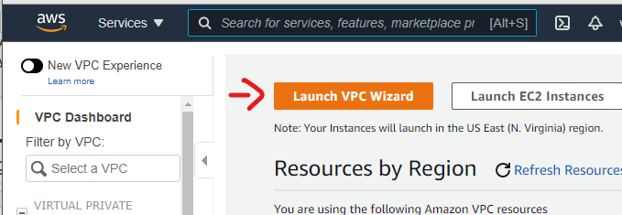

**2)Click on Select**

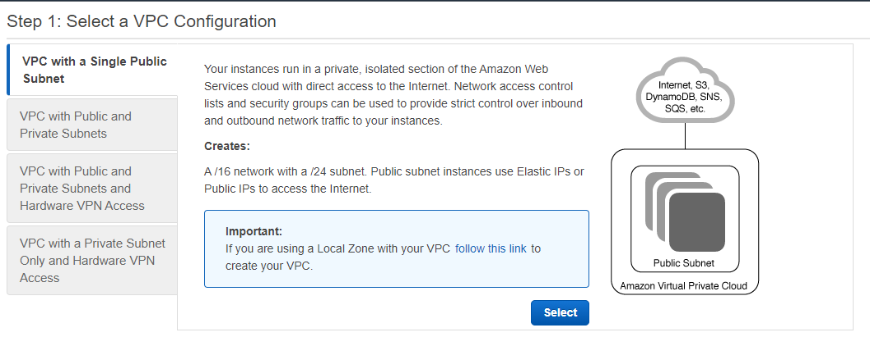

Availability zones (AZs) are isolated locations within data center regions from which public cloud services originate and operate. If power outage does happen in one location, you can fall back on to other locations.

**3)Create subnet**

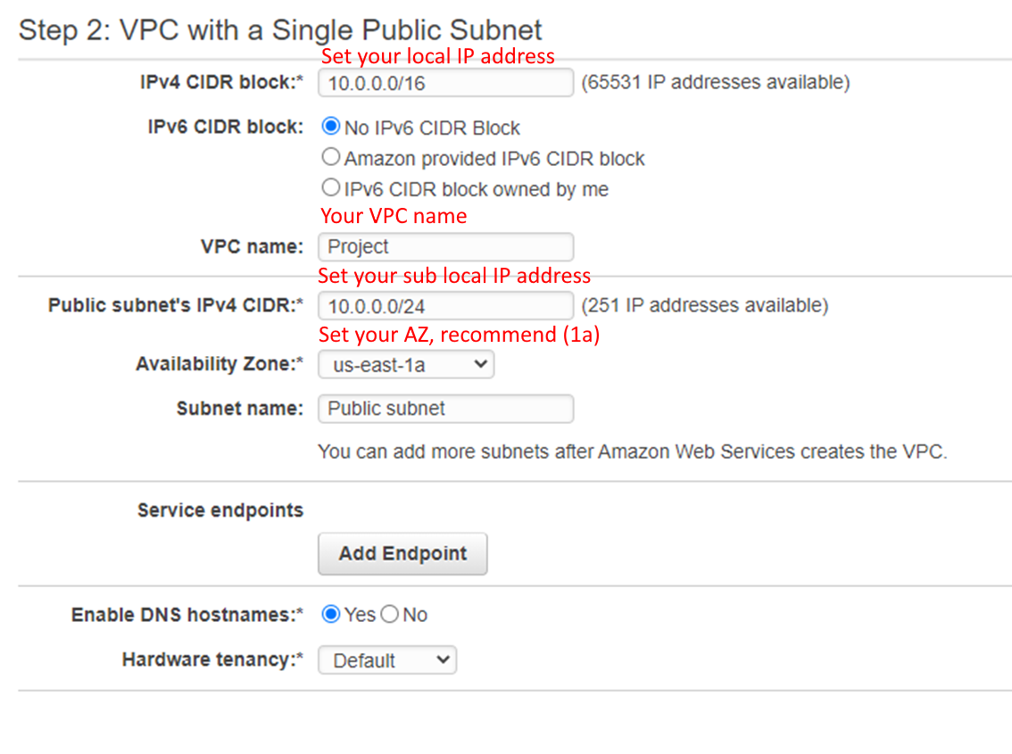

**This creates the following tasks:**

* Your VPC which is your entire local IP address,
* Your subnet, which is in the availability zone us-east-1a,
* Internet Gateway
* A routing table, which router all traffic from inside through the internet gateway

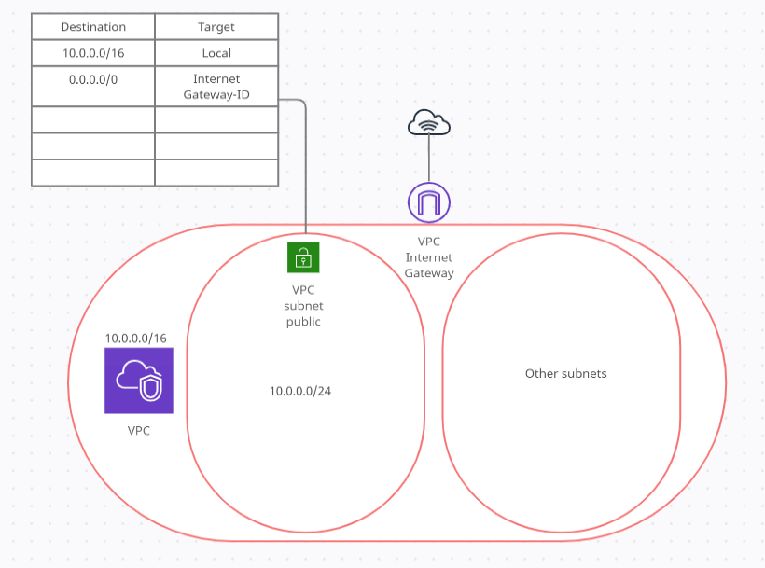

* **VPC topology**

B) Creating your instance

**1)Head over to the EC2 dashboard**

**2)Click on the Launch Instance button (as shown below).**

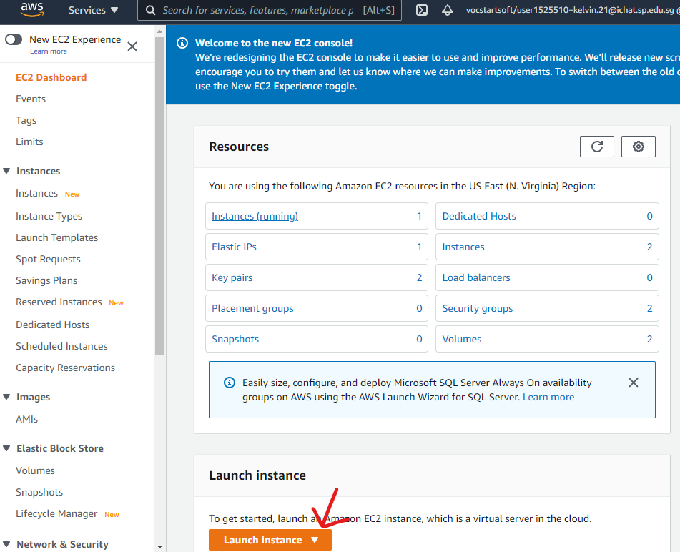

**3)Choose AMI**

You will have the option to select your amazon Machine Image. Which is basically an ISO you can launch from, as your Operating System.

You will be choosing Ubuntu Server 18.04 LTS (64-bit).

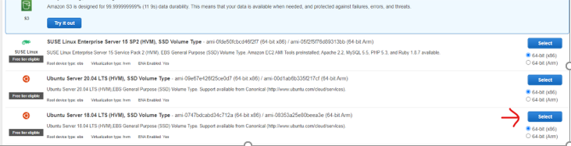

**4)You will choose t2.micro, which provides 1vCPU and 1 GB memory offered by AWS as a free tier**

**5)Click on Next: Configure Instance Details for further configurations**

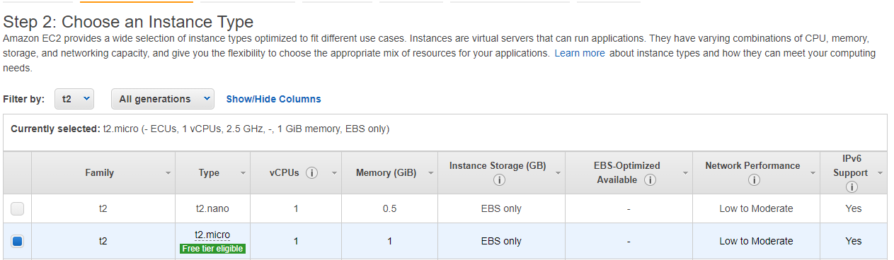

6)**You will be asked to select a VPC, you can either use the default VPC which amazon creates by default-or use the VPC which you have created previously in step A.**

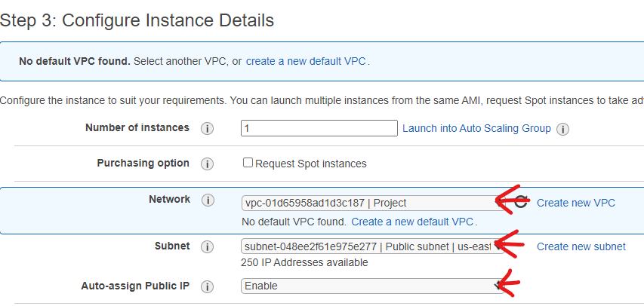

**You can add extra storage for backup purposes or increase the size of the storage (Optional)**

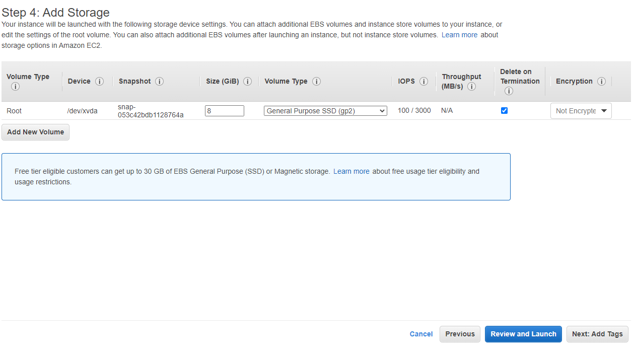

7)**The security group is the firewall for your instances, it determines who can connect to the port. Since we are hosting a WordPress instance, we will need enable SSH, HTTP, HTTPS**

If you are the only person connecting to the Instance, it is recommended to set the SSH source to your IP

It is also **HIGHLY** recommended to set your HTTP/HTTPS to your IP address when setting up WordPress as you will need to change the password of the site by connecting through HTTP/HTTPS.

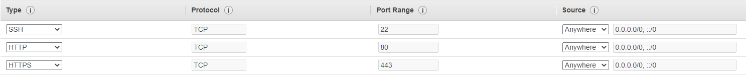

**8)Launch the instance by clicking on "Launch".**

**9)You will see this alert, you will need to create a new key pair and download it in order to SSH to your server.**

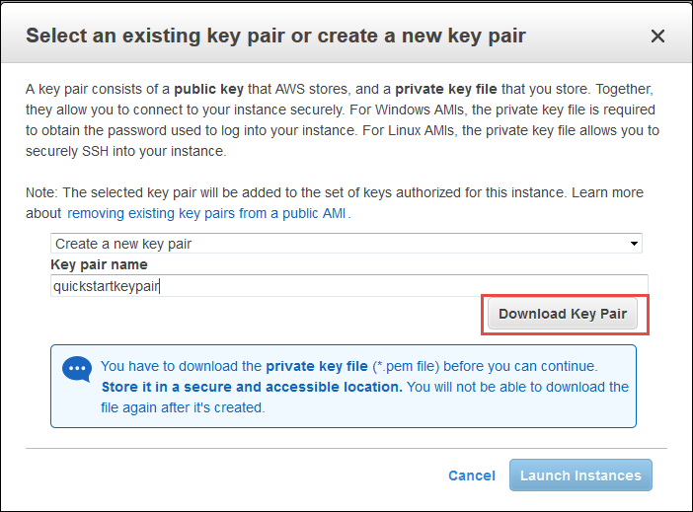

C) Create your DNS (Optional)

**1)Get a domain name from your domain provider (We won’t be going through this)**

**2)Head over the Route 53 dashboard**

**3)Insert your domain name under the domain name option**

**4)Set type to Public hosted zone**

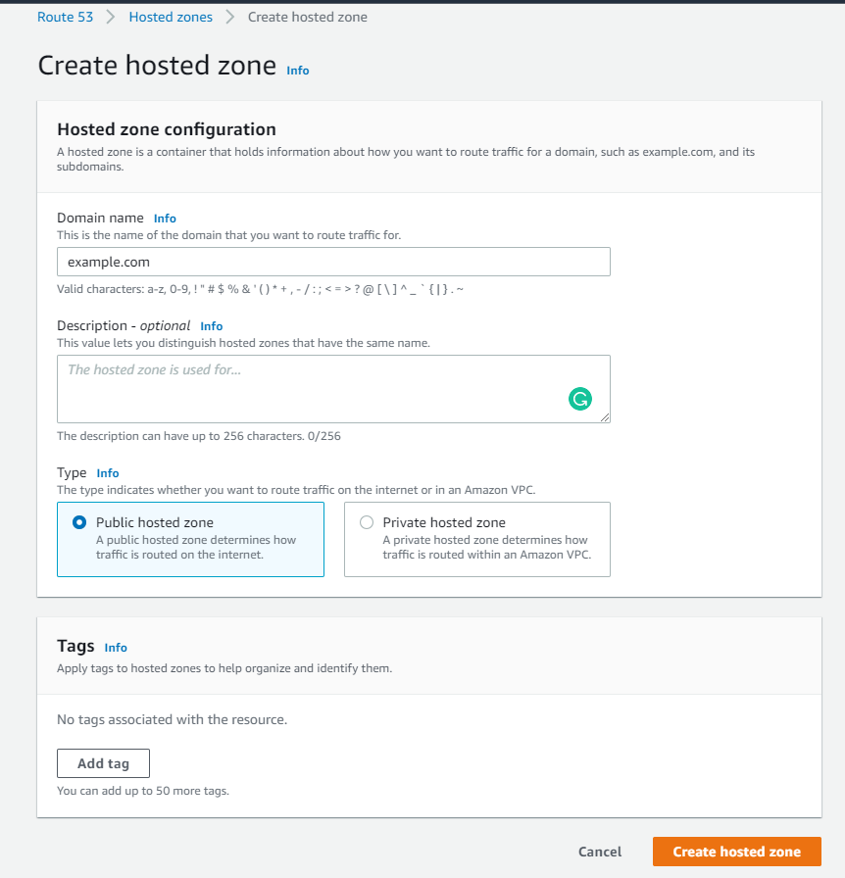

**5)On your domain provider set it to point to the 4 nameservers**

**6)create an A record which points the domain name to your EC2 IP address**

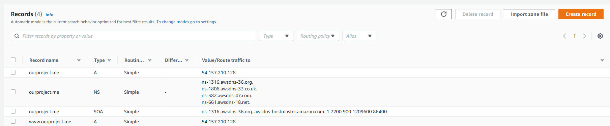

D)Connecting to the Created Remote Instance

**1)We will be using the Application “mobaxterm” to connect to the created instance, you can download it here (**[**mobaxterm download**](https://mobaxterm.mobatek.net/download.html)**)**

**2)Select the home edition**

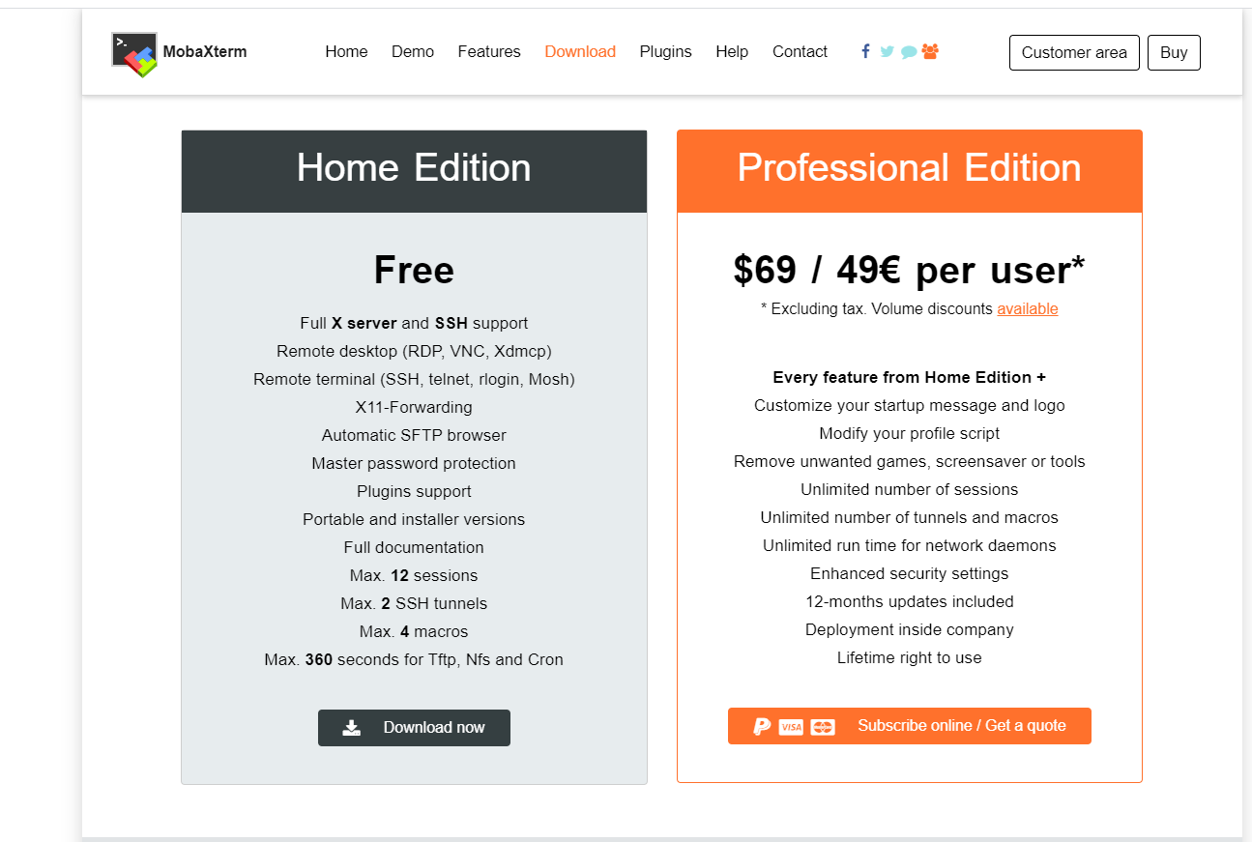

**3) Enter the IP address of your instance under the "remote host section" , your Ubuntu username under the "specify username section" and the private key on the "use private key section"**

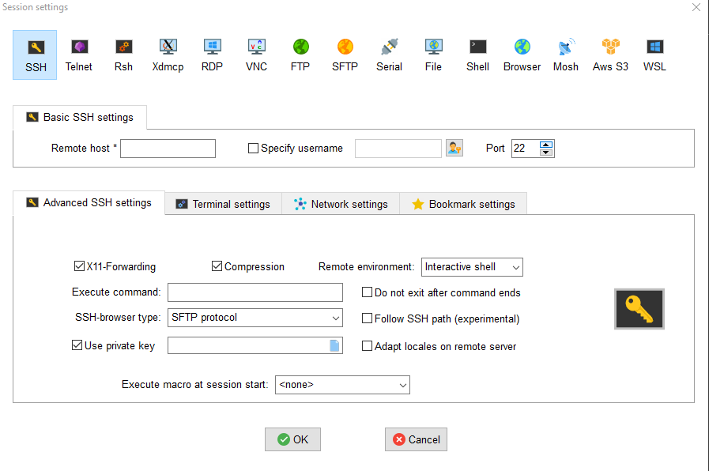

**4)You should have successfully SSH into the instance**

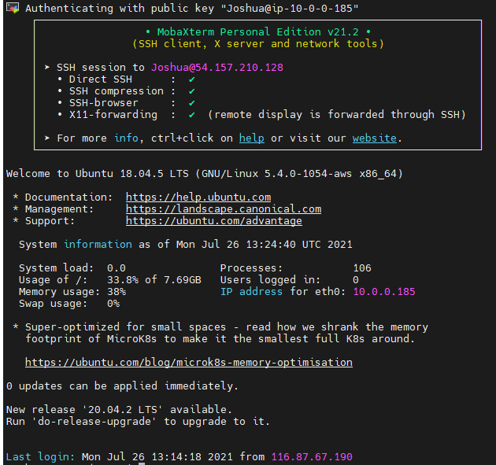

*Recommended to work in root!

1) Creating additional user account and configuring SSH key

1)open the terminal and use the useradd command,the last value would be the username of the user added

* **useradd -m -s /bin/bash Joshua**

2)Log into the account added previously, open the terminal and generate your SSH key

* **sudo su root**
* **mkdir /home/Joshua/.ssh**
* **ssh-keygen -t ed25519**

**\*Enter password of the key (Recommended)**

* **mv id_ed25519.pub authorized_keys**

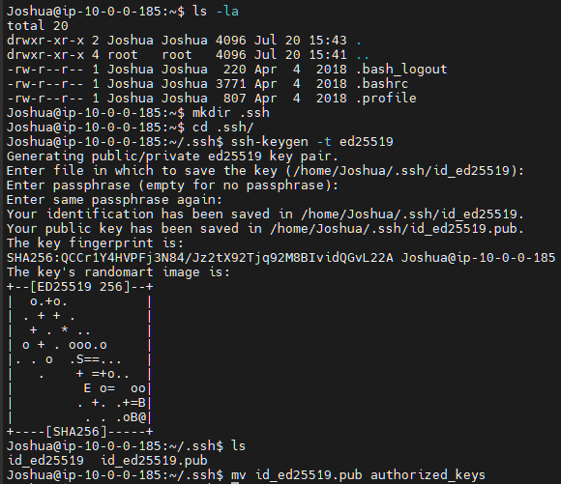

3)Grant permission to use SFTP to download private key

* **chmod 777 id_ed25519**

4)Download key on the side panel of mobaxterm (Easiest way) (Alternative use scp)

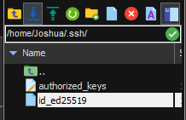

5)Give correct permissions





2) Installing wordpress

1) Download the following package information

2)Download wordpress zip file

* **wget https://wordpress.org/latest.tar.gz**

3)Unzip the downloaded wordpress zip file

* **mkdir -p /var/www/html**
* **tar --strip-components=1 -xvzf latest.tar.gz -C /var/www/html/**

4)Remove the zip file

* **rm /var/www/html/latest.tar.gz**

5)Keep sample config file as backup and copy sample to use

* **cp /var/www/html/wp-config-sample.php /var/www/html/wp-config.php**
* **mv wp-config-sample.php ..**

6)Create website directory and configure apache2 to point to the created directory

* **mkdir /var/www/html/**
* **sed -i -e "s_<Directory /var/www/>_<Directory /var/www/html/ >_" /etc/apache2/apache2.conf**

7)Grant ownership of /var/www to www-data

* **chown www-data:www-data -R /var/www**

8) Configure the directory permissions of /var/www

* **chmod 775 -R /var/www**

9)Restart apache server to apply changes

* **systemctl restart apache2**

3) Setting up MySQL

1)To get started we first need to download the **package information**

* **sudo apt update**

2)We will then install MySQL

**sudo apt install mysql-server**

3)We will run the security script after MySQL installation

**sudo mysql_secure_installation**

* There will be multi prompts which would configure the security options of MySQL,for the first prompt,you will be asked I you would like to set up the Validate Password Plugin, either option is fine, by we decided to set it up, **click “Y”**
* There will be 3 different levels of password validation policy,choose **MEDIUM**
* Password used**:p@ssW0rd**

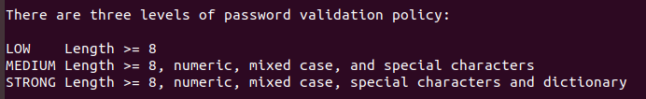

* Click Y for the remaining prompts to accept the defaults

4)Creating database and data base users on my SQL

Log in into mySQL as root user

* **mysql -u root -p**

Create data user "wordpress-user" with password "p@ssW0rd"

* **CREATE USER** **'wordpress-user@'localhost' IDENTIFIED BY 'p@ssW0rd';**

Verify if the user is successfully created

* **SELECT user,authentication_string,plugin,host FROM mysql.user;**

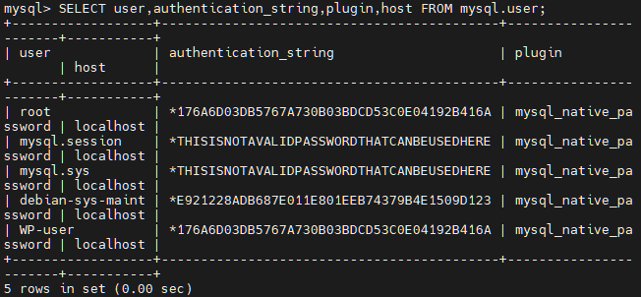

CREATE database

* **CREATE DATABASE** **`wordpress-db`;**

Assigning full privileges to previously create database and user

* **GRANT ALL PRIVILEGES ON `wordpress-db`.* TO 'wordpress-user'@"localhost"**

Reloads the grant tables in the mysql database enabling the changes to take effect without reloading or restarting the service

* **FLUSH PRIVILEGES;**

4)Configure HTTPS using CertBot (OPTIONAL)

1) Install snapd

* **sudo apt install snapd**

2)Check if it is up to date

* **sudo snap install core; sudo snap refresh core**

3) Ensure that your version of certbot is up to date

* **sudo apt-get remove certbot**

4) Install Certbot

* **sudo snap install --classic certbot**
* **sudo ln -s /snap/bin/certbot /usr/bin/certbot**

5)Set up HTTPS with certificate

* **sudo certbot –apache**

5)Security (OPTIONAL)

1a)Format EBS

* **sudo mkfs -t ext4 /dev/xvdf**

1b)Mount created EBS

* **mkdir /Logs**
* **mount /dev/xvdf /Logs**

1c)Mount on reboot

1d)Change in all /etc/apache2/sites-available

1e)Disable and enable all and restart apache2

* **a2dissite \***
* **a2ensite \***
* **systemctl reload apache2**

2)Point all history to /dev/null on root and all users

* **ln -sf /dev/null .bash_history**
* **ln -sf /dev/null .mysql_history**

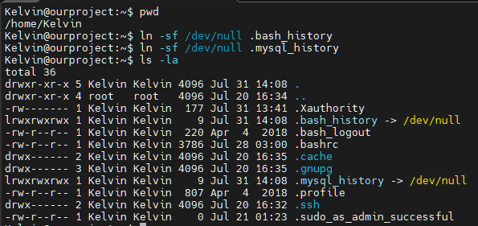

**3)Disable history**

**For newly created users**

* **echo 'set +o history' >> /etc/profile** (As root)

For current users

* **echo 'set +o history' >> ~/.bashrc**

clear history

* **history -c**

4)Enable SSH logging

sudo systemctl enable apache2 && sudo systemctl enable mysql

